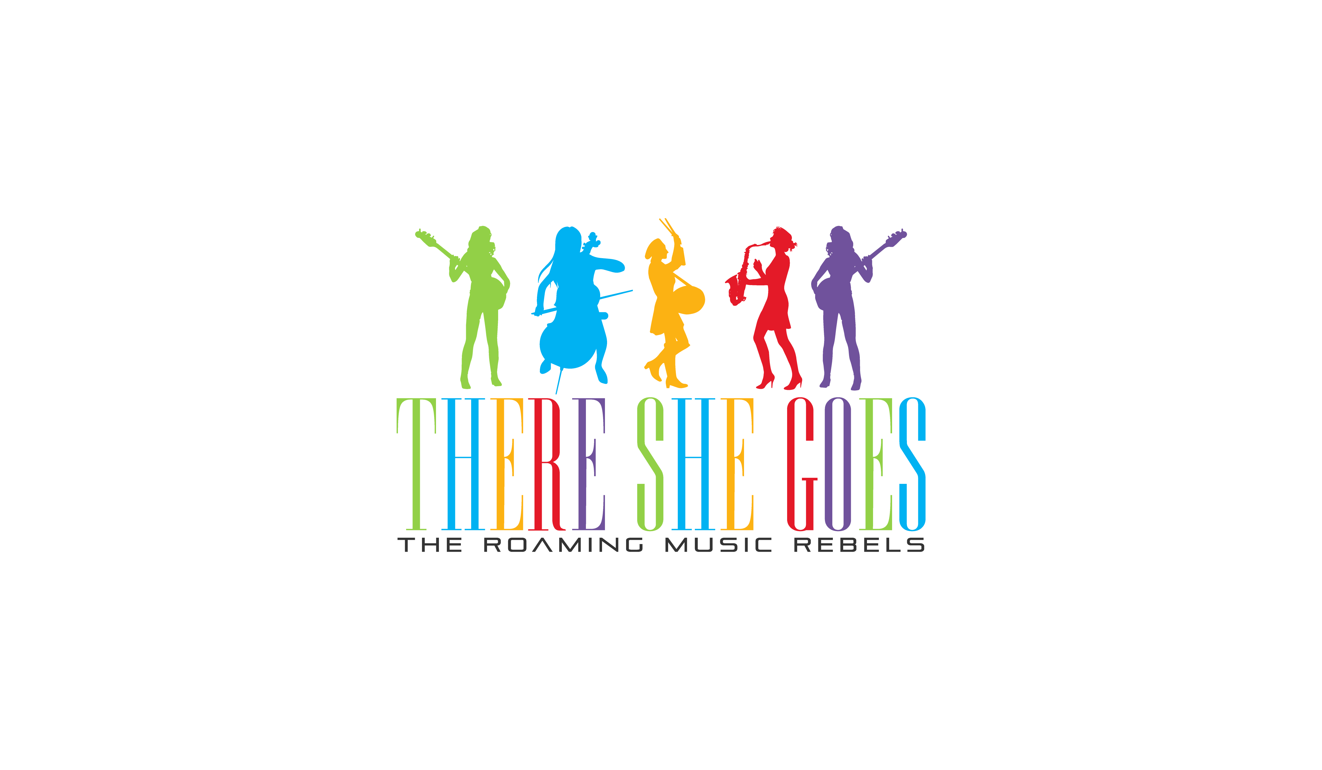
There She Goes Sample Set List
3 x 30 Mins or 2 x 45 Mins

The Chilled Zone
- All Night Long – Lionel Richie
- Ho Hey – The Luminers
- Stand By Me – Ben E King
- My Girl – The Temptations
- English Man In New York - Sting
- I’m Yours – Jason Mraz
- The Way You Make Me Feel – Michael Jackson
- Royals - Lorde
Party Party!
- 24k Magic – Bruno Mars
- Happy – Pharell
- Push It–Salt n Peppa
- Proud Mary – Tina Turner
- Wannabe – The Spice Girls
- Here Comes The Hotsteppa (Murdera) – Ini Kamoze
- Jailhouse Rock – Elvis Presley
- Hot Hot Hot - Arrow
Sing-A-Long Classics

- Can’t Hurry Love – The Supremes
- Brown Eyed Girl – Van Morrison
- Girls Just Wanna Have Fun – Cindy Lauper
- Sax – Fleur Eastwood
- There little Birds – Bob
- Kiss – Prince
- Ain’t Nobody – Aretha Franklin
- Valerie – Amy Winehouse

You can also chose from our new very popular Show Tunes selection!

- America – West Side Story
- Bare Necessity – Jungle Book
- Big Spender – Sweet Charity
- Do-Re-Mi – The Sound Of Music
- Fame – Fame
- He’s A Tramp – Lady and the Tramp
- I Feel Pretty – West Side Story
- I Wanna Be Like You – Jungle Book
- I'd Do Anything – Oliver
- If I Were A Rich Man – Fiddler On The Roof
- Oom-Pah-Pah – Oliver

- Please note we have an extensive repertoire and create a bespoke set list for each and every client, but for privacy reasons we do not display our full list on our public website. (we can’t give away all of our secrets ;-)

For our extensive song list, please get in touch info@shemusicglobal.com

